

Department of B.Tech Artificial Intelligence and Data Science

Naan Mudhalvan

PROJECT REPORT

Importing & Securing Data in ServiceNow

Submitted By: TEAM 6
- Roshini B
- Karthikeyan S (303)
- Darshana M
- Dharshini P
- Karthikeyan S (25)

Under the Guidance of
- Ms Jasmine Juline. Y

Academic Year
2026-2027

Technology Used
ServiceNow

1 Executive Summary & Project Overview
1.1 Executive Summary
Modern enterprise operations demand centralized tracking of workforce development while maintaining strict data governance standards. This project delivers an end-to-end implementation within the ServiceNow platform to manage employee training records. The architecture covers custom database table creation, bulk data ingestion via Import Sets, dynamic relational mapping through Dot-Walking, and strict Role-Based Access Control (RBAC) enforced by platform Access Control Lists (ACLs).
1.2 Core Project Scope
- Data Structure Design: Constructing a dedicated table (u_employee_training_records) with typed dictionary entries.
- Automated Data Integration: Staging external spreadsheet data and transforming field values into target table columns using Transform Maps.
- Relational Reporting: Utilizing ServiceNow's Dot-Walking feature to expose referenced sys_user details (e.g., Department) dynamically.
- Security & Governance: Elevating privileges to security_admin, defining custom roles (Hr Manager), and building record-level ACLs for read and write operations.
- Validation: Verification of security rules through user impersonation workflows.

2 Problem Statement & Objectives
2.1 Problem Statement
Organizations frequently track employee certifications and course completions across disconnected spreadsheets. This manual practice introduces data redundancy, lacks real-time visibility into employee department alignments, and exposes sensitive training history to unauthorized personnel without governance.
2.2 Objectives
- Centralize Records: Design a custom table to log course titles, completion dates, training statuses, and assigned employees.
- Automate Ingestion: Load bulk records into staging tables and execute field transformations without manual data entry.
- Optimize Data Relationships: Reference the platform's core sys_user table and pull related fields seamlessly using dot-walking.
- Enforce Security Policy: Restrict table access so only designated roles (e.g., HR Managers) can view or modify records, while general users remain restricted.

3 Milestone 1: Custom Table Design & Schema Configuration
3.1 Table Creation
To hold all employee training activity, a custom table was created within the ServiceNow platform under the Global application scope.
- Navigation Path: All $→$ System Definition $→$ Tables $→$ New
- Label: Employee Training Records
- Name: u_employee_training_records
- Application Scope: Global
- Auto-Generated Navigation: Created custom application menu and module entries automatically (Employee Training Records).
3.2 Field & Dictionary Entries Setup
Under the Columns tab, custom fields were added with appropriate data types and reference rules to structure the table layout properly:
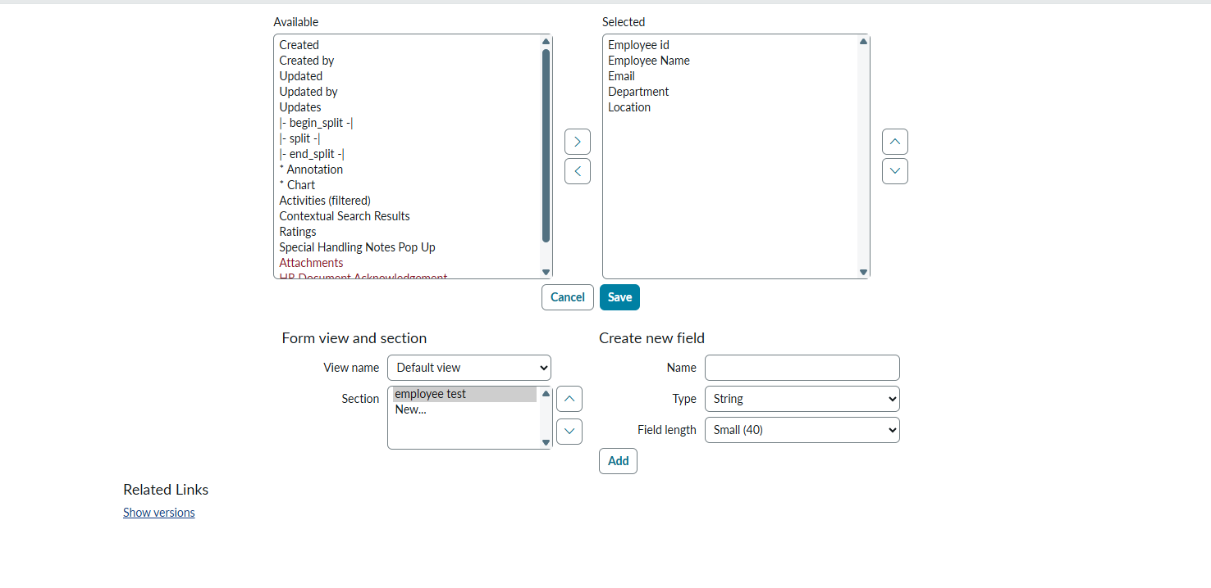
3.3 Choice List Configuration
For the Status field, a custom choice list was configured within the Dictionary Entry settings to ensure standardized inputs:
- In Progress: Value = ip
- Completed: Value = c

4. Milestone 1: Data Import, Staging, and Transform Mapping
4.1 Data Preparation & Import Set Ingestion
- Spreadsheet Setup: An external dataset (Employee Training.xlsx) was prepared with bulk training records containing training names, completion dates, statuses, and target employee names/emails.
- Data Loading:
  - Navigation Path: All $→$ System Import Sets $→$ Load Data
  - Import Set Table Label: Employee Training
  - Import Set Table Name: u_employee_training
  - Source File: Employee Training.xlsx
  - Execution Status: 19 records processed successfully into the staging table.
4.2 Transform Map Creation & Field Mapping
To map incoming staging data from u_employee_training to the target database table u_employee_training_records, a dedicated Transform Map was created.
- Navigation Path: All $→$ System Import Sets $→$ Administration $→$ Transform Maps
- Name: Employee Transform
- Source Table: Employee Training (u_employee_training)
- Target Table: Employee Training Records (u_employee_training_records)
- Enforce Mandatory Fields: No
- Copy Empty Fields: False
4.3 Field Maps Setup
Field relationships were explicitly configured to establish exact mapping between staging fields and target database columns:
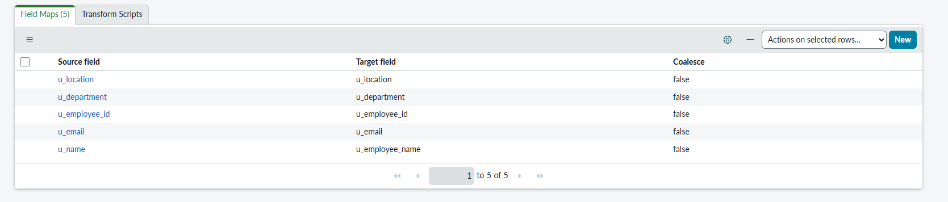
4.4 Transformation Execution
- Action: Selected Transform under Related Links.
- Execution Result:
  - State: Complete
  - Completion Code: Success
  - Message: Transformation complete
  - Errors Logged: 0

5. Milestone 3: Data Relationships & Dot-Walking
5.1 Dynamic Field Access Setup
Instead of duplicating user data across tables, ServiceNow's Dot-Walking mechanism was leveraged to pull live employee attributes directly through the Employee (sys_user) reference field.
5.2 Form Layout Configuration
- Navigation Path: All $→$ Employee Training Records $→$ Employee Training Records $→$ New
- Action: Opened Additional Actions (context menu) $→$ Configure $→$ Form Layout.
- Dot-Walking Procedure: Expanded the Employee [+] reference element in the Available column, selected Department, and moved it into the Selected layout section.
- Outcome: Employee.Department renders dynamically on both form view and list view without requiring custom backend triggers or data redundancy.

6. Milestone 4: User Administration & Custom Role Allocation
6.1 Custom User Creation
To test role-based permissions, a test account was provisioned in the instance.
- Navigation Path: All $→$ User Administration $→$ Users $→$ New
- User ID: backup user
- Identity Type: Human
- Active: True
6.2 Custom Role Creation
A dedicated administrative role was created to govern access to all employee training functionality.
- Navigation Path: All $→$ User Administration $→$ Roles $→$ New
- Name: Hr Manager
- Application Scope: Global
6.3 Role Assignment & Application Menu Protection
- Assigning Role to User: Opened backup user, navigated to the Roles related list, clicked Edit, and added the Hr Manager role.
- Securing Menus & Modules:
  - Navigated to All $→$ Employee Training Records (Application Menu edit icon) and assigned required role: Hr Manager.
  - Navigated to All $→$ Employee Training Records $→$ Employee Training Records (Module edit icon) and assigned required role: Hr Manager.

7. Milestone 5: High-Security Access Control Lists (ACLs)
7.1 Security Privilege Elevation
- Action: Selected system profile header $→$ Elevate Role.
- Selection: Checked security_admin box to enable modifications to High Security Settings and ACL rules.
7.2 Read & Write ACL Rules Configuration
Two record-level Access Control Lists were created for the custom table:
- Read ACL Rule:
  - Type: Record
  - Operation: read
  - Name: Employee Training Records [u_employee_training_records]
  - Requires Role: Hr Manager
  - Description: Allows read access for records in u_employee_training_records exclusively for users holding the Hr Manager role.
- Write ACL Rule:
  - Type: Record
  - Operation: write
  - Name: Employee Training Records [u_employee_training_records]
  - Requires Role: Hr Manager
  - Description: Allows write/update access for records in u_employee_training_records exclusively for users holding the Hr Manager role.

8. Milestone 6: Testing & Security Validation
8.1 Impersonation Testing
User impersonation was used to verify Role-Based Access Control (RBAC) and Access Control Lists (ACLs) across authorized and unauthorized accounts.
8.2 Test Results
- Test Case 1: Authorized Access (backup user with Hr Manager role)
  - Behavior: The Employee Training Records module was visible. Records were readable, editable, and dot-walked department fields loaded correctly.
  - Result: PASSED — Full access granted.
- Test Case 2: Unauthorized Access (Standard user without Hr Manager role)
  - Behavior: The module was hidden from the navigator. Direct URL navigation was blocked by record-level ACLs.
  - Result: PASSED — Access denied.

Project :
https://nowlearning-nlinst04739427-9t3me-0001.lab.service-now.com/now/nav/ui/classic/params/target/import_status.do%3Fsysparm_pworker_sysid%3D833916b2552b03107f4480c487abe67c%26sysparm_run_history%3Dundefined
file imported project link:
https://nowlearning-nlinst04739427-9t3me-0001.lab.service-now.com/now/nav/ui/classic/params/target/u_employee_test_list.do%3Fsysparm_userpref_module%3D219e06b255e703107f4480c487abe6cb%26sysparm_clear_stack%3Dtrue%26sysparm_clear_stack%3Dtrue
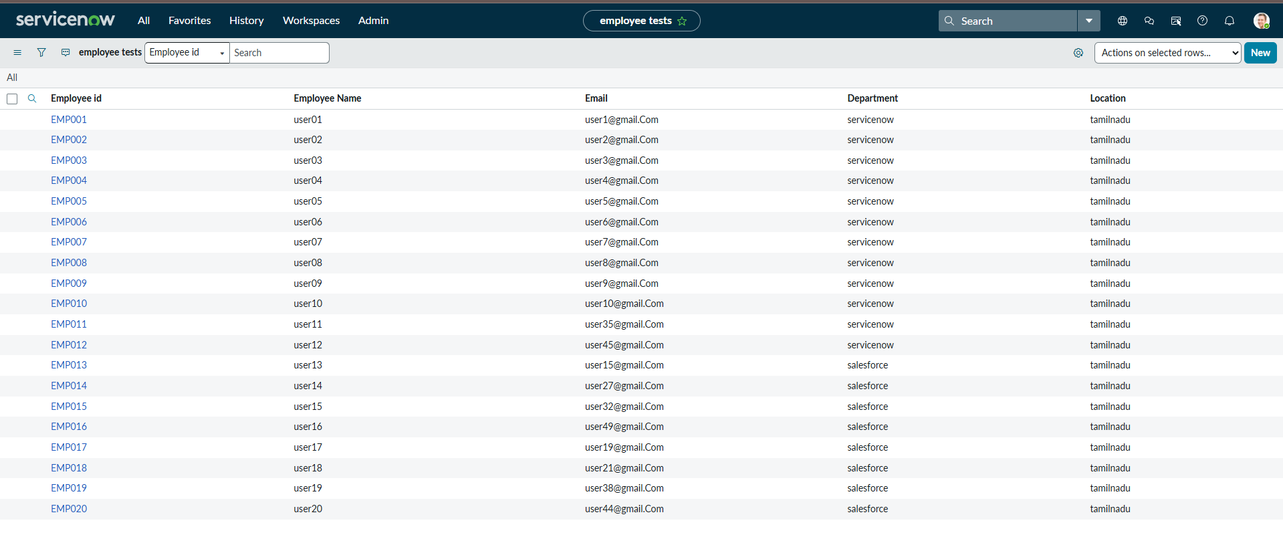

9. Conclusion
This project successfully implemented an end-to-end ServiceNow data management and security solution. By combining custom table design, Import Sets, Dot-Walking, and ACL-based role security, the platform ensures accurate data integration and strict security compliance.

